**Name: Sreelakshmi M Nair**

**Roll No: 40**

**Batch: B**

**Date: 04/04/2022**

**NETWORKING & SYSTEM ADMINISTRATION LAB**

**Experiment No.: 3**

**Aim**

Familiarization of the linux commands.

**Procedure**

**36. cp**

This command is used to copy the contents from an existing file to a new file.

Syntax :- $ cpexisting_filenamenew_filename

Output :-

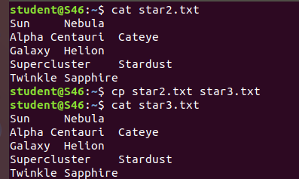

**37. cp -r**

This command is used to copy a directory along with its subdirectories.

Syntax :- $ cp -r source_directorydestination_directory

Output :-

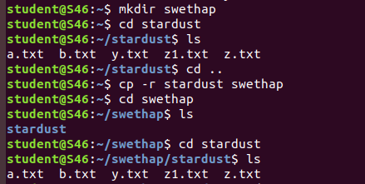

**38. cp overwriting**

This method is used to overwrite the contents of an existing file from one directory to an existing file with the same name in another directory with the cp command.

Syntax :- $ cp filename directoryname

Output :-

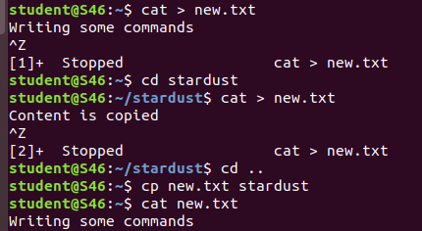

**39. cp-i**

This command is used to ask the confirmation message once before overwriting the file. We give ‘y’ or ‘n’ as the response.

Syntax :- $ cp -i filename destination_directory

Output :-



**40. mv**

This command is used to move an existing file or directory from one location to another.

Syntax :- $ mv filename directory_name

Output:-

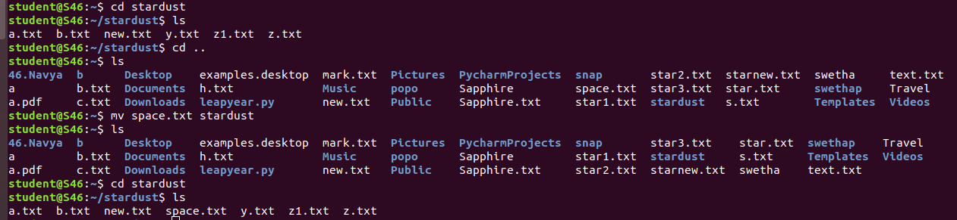

**41. mv overwriting**

This method is used to overwrite the contents of an existing file from one directory to an existing file with the same name in another directory with the mv command.

Syntax :- $ mv filename directory_name

Output :-

